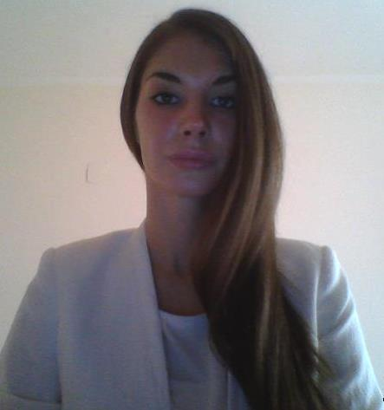**Name: Marija Sijan**

**Date and place of birth : 28 March 1990 , Belgrade**

**Address : Patrisa Lumube, 30/6, Belgrade**

**Telephone number : +381 62 770 579**

**E - mail: sijanmarija@yahoo.com**

**EDUCATION**

**Department of Political Science,University of Belgrade**

2008 /

International Relations, International Politics

*two exams until graduation

**BusinessAcademy , Zemun**

October 2011/ October 2012

Certified Project Manager

Cambridge Diploma in Business - in progress

Final Exams :

• Business Environment and Organization

• Effective Business Communication

• HR Management

• Marketing

**Zemun High School, Belgrade**

2004 / 2008

**WORK EXPERIENCE**

**PR / Event Manager Assistant,** *European Union Information Centre - Volunteer*

The Delegation of the European Union to the Republic of Serbia

December 2013 / March 2014

Job Description:

Assisting in writting project proposals; Taking part in event organization and realization; Translating and proofreading; Press clipping; Assisting in writting media plan; Communication with (potential) partners via phone, email; Attending the meetings and keeping records; Working on creative solutions for campaigns; Writting news; Reporting

**Freelancer, Marketing Manager Assistant ,** *Empire Ltd., Budva - temporary assignment*

October 2013 / Januar 2013

Job Description:

Contacting companies in order to establish business cooperation; Writing initial proposals for business cooperation; Business communications; Market Research; Group Targeting; Design and Implementation of the Marketing Strategy;

Accomplishments:

Business colaboration with several companies, meeting organization.

**Office Manager ,** *Attorney Office "Milorad Vlahovic"*

October 2012 / September 2013

Job Description: Performing administrative tasks; Organization of meetings; Agenda monitoring; Maintaining effective communication among employees; Advisory role in communicating with the

employer

**Intern ,** Committee on Defense and Security, National Assembly of the Republic of Serbia

February 2012 / September 2012

**Certificate for successful participation in professional practice at National Assembly**

Job Description : Administrative assistance; Preparation of presentations; Conducting presentation during the meetings; Normative acts preparation; Monthly reports to NGO which recruited me

Accomplishments: Certificate for successful participation in professional practice NS

**Sales Assistant ,** Hoby shop, Svilajnac / Belgrade

2008 / 2011

Job description: Sales; Customer support; Design showcase;

**LANGUAGE SKILLS**

Serbian : Native speaker

English : Fluent

**COMPUTER LITERACY**

Proficiency in use of Office package (Word , Excel , PowerPoint ) and Internet.

**PERSONAL CHARACTERISTICS**

• Responsible , systematical , organized

• Communicative

• Fast learner who strives for development

• Great under pressure

• Team player

• Flexible and dedicated

**REFERENCES**

References available upon request.

**ADDITIONAL EDUCATION**

TRAININGS

National Democratic Institute, Kralja Milana 14, National Assembly

• About the Law of National Assembly of the Republic of Serbia, Birth of Law, Rules of Procedures, and the role of Working Bodies in legislation procedure ( March / 2012)

• Teamwork ( April /2012 )

• Strategic planning / thinking ( June /2012)

• Negotiation ( June/ 2012 )

• Writting Project ( July /2012 )

• Public speaking ( September /2012 )

COURSES

Business Academy, Zemun

• Microsoft Word 2010 ECDL

• ECDL Microsoft Excel

• ECDL Microsoft Power Point

• ECDL for Windows 7 users

• ECDL Internet

• ECDL Microsoft Access

• ECDL IT

• Assessment of English

• English - Intermediate

• Business English

• Business Etiquette

• Environmental Management

• Risk Management

• Management issues in the project

• Project Portfolio Management

• Creativity and innovation

• Style and personal marketing

• Career Planning

• Principles of enrichment and investment

• Management of contracts and documents

• Legal aspects of project management

• Project management in various industries

• Methods and techniques of project management

• Program Management