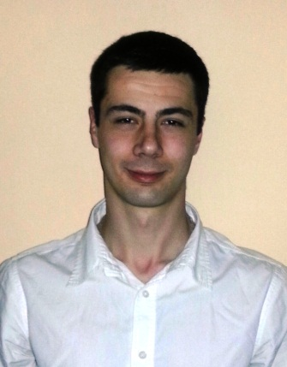**Curriculum Vitae**

**LUKA VLAHOVIĆ**

Date of birth: 3.1.1991.

Adress: Pere Ćetkovića 64, Belgrade

Phone number: +38111 2775 789

Cell phone: +38160 5775 789

E- mail: [lukavlah@gmail.com](mailto:lukavlah@gmail.com)

**Education**

* University degree in Information Systems and Technologies (October 2009 - May 2014)

Faculty of Organizational Sciences, University of Belgrade

* Fifth Belgrade High School (2005 - 2009).

**Experience**

* Andreja DOO, import-export company

Freelance Programmer, developing Android application for sales department (June 2014 – August 2014)

* Andreja DOO, import-export company

Freelance Programmer, developing Android application for sales department (November 2013 – January 2014)

* Pakom, computer sales and distribution

Call Centre Operator (June 2010 – Septembre 2010)

**Projects**

* Created website for import-export company with Joomla CMS (March 2014)
* Developed program for airport flight control in C# (February 2014)
* Developed car ads Android application (July 2013)
* Created website for movie theater using only Notepad+ (January 2013)
* Developed chat application in Java (January 2012)
* Created website for video games with Joomla CMS (June 2011)

**IT skills**

* Very skillful and experienced in Android development with eclipse framework
* Good knowledge and experience in Java and C# programming
* Solid knowledge and experience with HTML, CSS, PHP, JavaScript...
* Experience in working with Joomla CMS and Wordpress
* Knowledge in SQL
* Basic knowledge about developement patterns
* MS Office

**Language**

* English - proficient
* German - intermediate

**Personal characteristics**

* Hardworking, responsible, persistent, results-focused, committed, willing to learn, teamwork oriented, work well under pressure, enjoy working in a challenging environment.

**Other**

* Driver license
* Interested in sports (played water polo for 4 years; training swimming since 10 years old)