|  |
| --- |
|  |

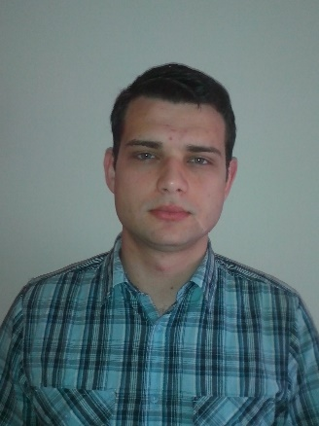Srđan Maravić

Date of birth: 17/03/1988   
Address: 4a Mića Radaković Street,  
 11080 Zemun, Serbia  
Cell phone: +381 66204290  
E-mail: [srdjanmaravic@gmail.com](mailto:srdjanmaravic@gmail.com)

LinkedIn: [rs.linkedin.com/in/srdjanmaravic/](http://rs.linkedin.com/in/srdjanmaravic/" \o "View public profile)

*Work Experience* Incident Manager – Internship FEB 2013 – MAR 2013  
 Telekom Srbija d.o.o.

Web Marketing Manager APR 2014 – JUN 2014

Consalteam Agency

Programmer/DBA/DBD JUN 2014 – SEP 2014

Mega Computer Engineering

*Education* IT Academy – Programming Department NOV 2013 – PRESENT  
 Direction: PHP Web Development

Faculty of Technical Sciences - 2007 – 2013  
 Kragujevac University  
 Direction: Informatics Engineer

Technical School 2003 – 2007  
 Direction: Electronics Technician

*Trainings* Database design and programming with SQL – Oracle Academy

MS SQL Server 2012 Database Fundamentals – Microsoft Virtual Academy

Querying Microsoft SQL Server 2012 Databases – Microsoft Virtual Academy

*Computer Skills* Advanced knowledge of MS Office (Word, Excel, PowerPoint)  
 Advanced knowledge of UML  
 Advanced knowledge of SQL  
 Advanced knowledge of HTML and CSS

Good command of PHP and JavaScript  
 Good command of Internet Marketing

Good command of Wordpress

Good command of computer networks

Good command of Apache administration

Good command of Linux/UNIX, Mac OS X

Basic knowledge of AJAX,JSON, AngularJS, Node.JS, GIT,C#

*Language Skills* English  
 (communication, writing, reading) – fluent

*Profile* - Efficient problem solving skills  
 - Excellent communication and interpersonal skills  
 - Quick identification of improvement possibilities  
 - Good time management  
 - Organized, systematic, analytical, accurate, proactive  
 - Complete dedication to work