Nikola Jovanović

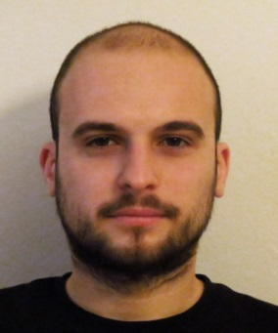
Personal Data
date of birth | January 6th, 1987
address | Ruzveltova 36, 11 120 Belgrade, Serbia
phone | +381 63 540 630
e-mail | nodzicar@gmail.com
 | Summary
 | Highly talented and motivated graduate of Faculty of Electrical Engineering of The University of Belgrade with strong academic background in telecommunications and networking, mathematics and physics. Has portfolio of independent works and projects in mathematics application in electrical engineering. Proven ability to work well in teams and in leadership positions.
 | Education
2005 – 2014 | BSc, Faculty of Electrical Engineering, University of Belgrade, Serbia  BSc in Telecommunications and Information Technologies, major: Systems Engineering  Expected graduation: January 2013, only graduate exam left
2001 – 2005 | Mathematical High School, Belgrade, Serbia  National school for students talented in mathematics  GPA 4.62/5.00, top 5% of student body  Member of physics competition team, worked in various mathematic, physics and biology workshops, contested in number of mathematics and physics national competitions. Won the 3rd prize in national physics competition in 2003.
 | Work Experience
2010 – June 2014 . | Faculty of Electrical Engineering Computing center, University of Belgrade  Operator  - Installing and maintaining local network infrastucture  - Maintaining computers, both hardware and software  - Providing assistance to students in using various software  - Working in shifts, including nights and weekends
July 2014 – October 2014 | System administrator at Finbet d.o.o Beograd
 | Computer Skills
MS Windows | Installation and configuration of operating system  Microsoft Office  Other Windows programs
Hardware | Knowledge of computer hardware, its installation and configuration
Languages | HTML, JavaScript, PHP, MySQL , BATCH scripting
 | Language Skills
Serbian | native speaker
English | negotiation level (written, spoken)
 | Personal Qualities
 | Hardworking, determined, motivated, pro-active person. Under intensive learning curve. Prepare to business traveling all around the world. Able to work under pressure and on tight deadlines. Experienced in management and leadership positions.
 | Areas of Interest
Programming
Hardware and software testing
WAN and LAN networks based on TCP/IP stack
Cisco Routing and Switching
Optical networks
Wireless networks
Public mobile systems
 | Rest
 | Hobbies and interests: football, basketball, playing guitar, accordion, reviewing movies and games
 | References
 | Boško Nikolić, professor, Faculty of Electrical Engineering, University of Belgrade
contact | nbosko@etf.bg.ac.rs, +381 64 120 6912

