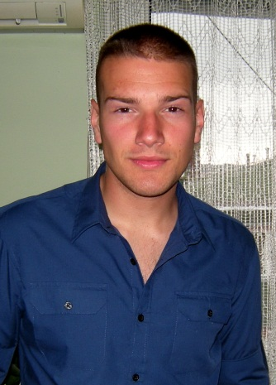Marko Milić

|  |  |
| --- | --- |
| **Date of birth** | 13. April 1990. |
| **Address** | Dragice Končar 6/27, Voždovac, 11000 Beograd, Serbia |
| **Home** | + 381 11 2494 068 |
| **Cell** | + 381 62 8972 271 |
| **E-mail** | marko.m1304@yahoo.com |

|  |
| --- |
| *Practical Work* |

|  |  |  |  |  |  |  |
| --- | --- | --- | --- | --- | --- | --- |
| o | Restaurant 'Orleans Waterfront Inn. Orleans, Massachusetts | **May** | **2014** | **-** | **Oct** | **2014** |
| o | Hotel MEĆAVNIK - Belgrade, Serbia | **Sep** | **2012** | **-** | **Oct** | **2012** |
| o | Travel agency “Evro - Tours” – Belgrade, Serbia | **Jul** | **2012** | **-** | **Aug** | **2012** |
|  |  |  |  |  |  |  |

|  |
| --- |
| *Education* |

|  |  |  |  |  |
| --- | --- | --- | --- | --- |
| o | Faculty of sciences – University of Novi Sad | **2013** | **-** | **Current** |
|  |  |  |  |  |
| o | College of tourism - Economy and tourism - Belgrade | **2010** | **-** | **2013** |
|  | Graduated with honors. |  | | |
|  |  |  | | |
| o | High school of gastronomy and tourism – Vrnjci Spa | **2006** | **-** | **2010** |
|  | Graduated with honors. |  | | |
|  |  |  | | |

|  |
| --- |
| *Profile* |

|  |  |
| --- | --- |
| **Languages** | Fluent in English; French –Beginner; Serbian – Native |
| **Computer Proficiency** | Microsoft Office Applications and Internet use |
| **Personal traits** | Ambitious, creative, likes team work, hard worker, resourceful, dedicated, responsible |